**Based On Meltzer Critical Reading Lesson #10**

**Vocabulary**

**I.**      **Prejudice - an unfair and unreasonable opinion or feeling, especially when formed without enough thought or knowledge.**

Sentence example - Laws against racial prejudice must be strictly enforced.

**II.**      **Disperse - to scatter or move away over a large area, or to cause this to happen.**

Sentence example - It took several hours for the crowd to disperse.

**III.**  **Usurpation - the act of taking control of something without having the right to, especially of a position of power.**

Sentence example - There are still those who regard the move as an unconstitutional usurpation of private property.

**IV.**  **Folly - the fact of being stupid, or a stupid action, idea, etc.**

Sentence example - It would be folly for the country to become involved in the war.

**V.**      **Scorn - a very strong feeling of no respect for someone or something that you think is stupid or has no value.**

Sentence example - She has nothing but scorn for the new generation of politicians.

**VI.**  **Ensnare - to catch or get control of something or someone.**

Sentence example - Spiders ensnare flies and other insects in their webs.

**VII.**      **Judicious - having or showing reason and good judgment in making decisions.**

Sentence example - We should make judicious use of the resources available to us.

**VIII.**      **Ruse - a trick intended to deceive someone.**

Sentence example - It was just a ruse to distract her while his partner took the money.

**IX.**  **Irreproachable - without fault and therefore impossible to criticize.**

Sentence example - Her conduct throughout was irreproachable.

**X.**      **Posterity - the people who will exist in the future.**

Sentence example - Every attempt is being made to ensure that these works of art are preserved for posterity.

**XI.**  **Amelioration - the process of making a bad or unpleasant situation better.**

Sentence example - Regular exercise can provide gradual amelioration of anxiety.

**XII.**      **Vice - a moral fault or weakness in someone's character.**

Sentence example - My one real vice (= bad habit) is chocolate.

**XIII.**      **Subterranean - under the ground. (adj.)**

Sentence example - These portals lead to subterranean passages that pass deep into the hillside, some of which have been blocked by earth falls.

**Based On SAT (Reading) Real Test (May 2017)**

**Vocabulary**

**I.**      **Pal - a friend.**

Sentence example - You're my best pal.

**II.**      **Vigorous - very forceful or energetic.**

Sentence example - There has been vigorous opposition to the proposals for a new road.

**III.**  **Single sb/sth out - to choose one person or thing from a group for special attention, especially criticism or praise.**

Sentence example - It's not fair the way my sister is always singled out for special treatment.

**IV.**  **Deem - to consider or judge something in a particular way.**

Sentence example - We will provide help whenever you deem it appropriate.

**V.**      **Prodigal - spending or using large amounts of money, time, energy, etc., especially in a way that is not very wise.**

Sentence example - There have been rumors that he has been prodigal with company funds.

**VI.**  **Liberal - respecting and allowing many different types of beliefs or behavior.**

Sentence example - Her parents were far more liberal than mine.

**VII.**      **Bountiful - large in amount.**

Sentence example - We found a bountiful supply of coconuts on the island.

**VIII.**      **Merit - the quality of being good and deserving praise.**

Sentence example - Brierley's book has the merit of being both informative and readable.

**IX.**  **Profuse - produced or given in large amounts.**

Sentence example - The company accepted blame and sent us profuse apologies.

**X.**      **Downcast - sad and without hope.**

Sentence example - I thought you were looking a little downcast this morning.

**XI.**  **Throb - a strong, regular beat.**

Phrase example - the throb of the engine.

**XII.**      **Ingenuous - honest, sincere, and trusting, sometimes in a way that seems silly.**

Sentence example - It has to be said it was rather ingenuous of him to ask a complete stranger to take care of his luggage.

**XIII.**      **Wary - careful because you do not completely trust someone or something or are not certain about what you should do.**

Sentence example - Teachers are often wary of standardized tests.

**XIV.**      **Shrewd - having or based on a clear understanding and good judgment of a situation, resulting in an advantage.**

Sentence example - She is a shrewd politician who wants to avoid offending the electorate unnecessarily.

**XV.**      **Thrifty - showing a careful use of money, especially by avoiding waste.**

Sentence example - They have plenty of money now, but they still tend to be thrifty.

**XVI.**      **Procure - to get something, especially after an effort.**

Sentence example - He'd procured us seats in the front row.

**XVII.**      **Mercenary - interested only in the amount of money that you can get from a situation.**

Sentence example - He had some mercenary scheme to marry a wealthy widow.

**XVIII.**      **Censure - strong criticism or disapproval.**

Sentence example - His dishonest behavior came under severe censure.

**XIX.**      **Prudent - careful and avoiding risks.**

Sentence example - It's always prudent to read a contract carefully before signing it.

**XX.**      **Fatigue - to make someone extremely tired.**

Sentence example - The journey had fatigued him.

**XXI.**      **Peril - great danger, or something that is very dangerous.**

Sentence example - I never felt that my life was in peril.

**XXII.**      **Evince - to make something obvious or show something clearly.**

Sentence example - They have never evinced any readiness or ability to negotiate.

**XXIII.**      **Render - to cause someone or something to be in a particular state.**

Sentence example - His rudeness rendered me speechless.

**XXIV.**      **Obscure - to prevent something from being seen or heard.**

Sentence example - The sun was obscured by clouds.

**XXV.**      **Felicity - happiness, luck, or a condition that produces positive results.**

Phrase example - the dubious felicity of marriage.

**XXVI.**      **Forbearance - the quality of being patient and being able to forgive someone or control yourself in a difficult situation.**

Sentence example - He thanked his employees for the forbearance (that) they had shown during the company's difficult times.

**XXVII.**      **Hinder - to limit the ability of someone to do something, or to limit the development of something.**

Sentence example - High winds have hindered firefighters in their efforts to put out the blaze.

**XXVIII.**      **Contentment - happiness and satisfaction, often because you have everything you need.**

Sentence example - More people were finding that material things do not bring contentment .

**MELTZER LESSON 10**

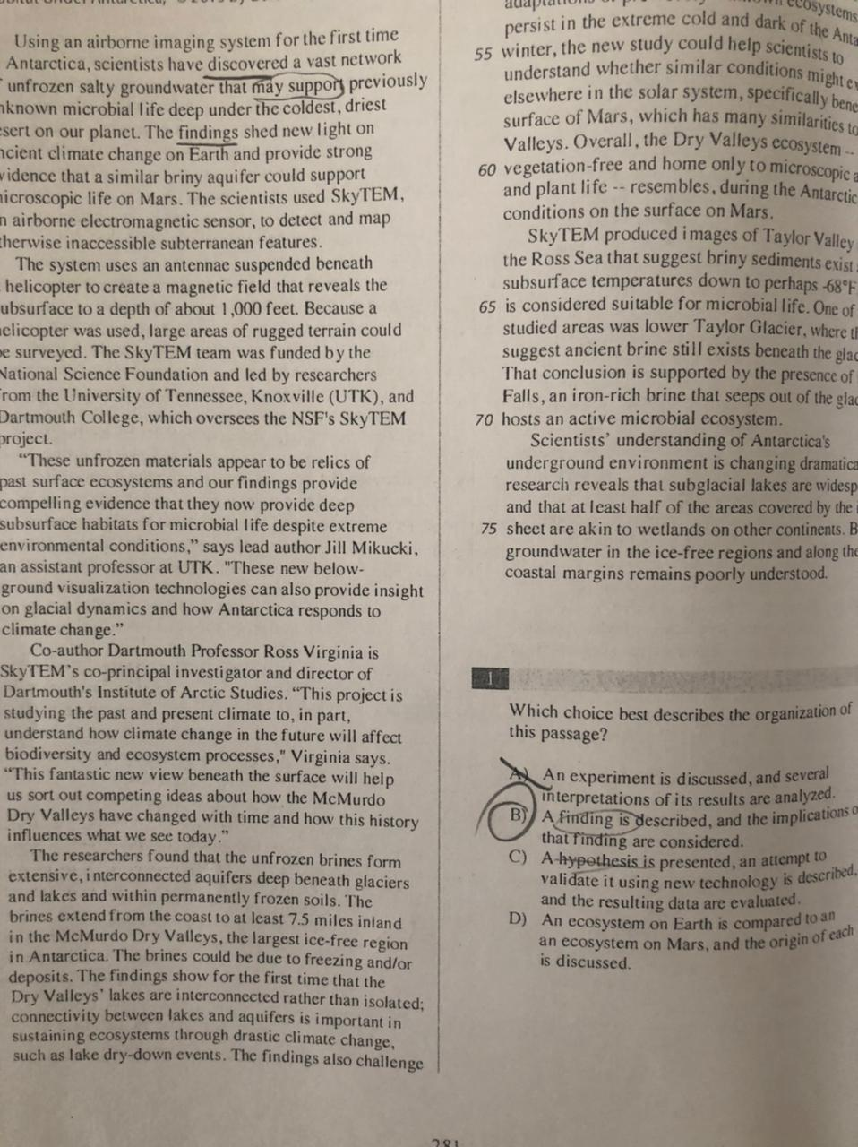

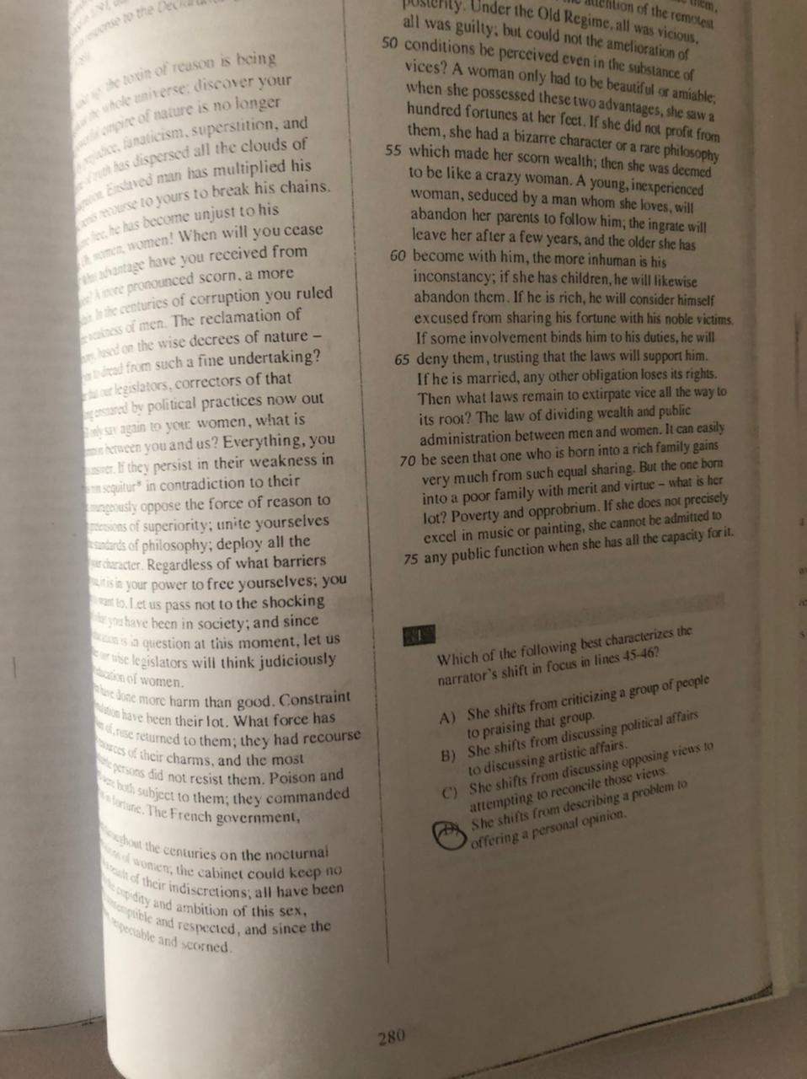

**SAT (Reading) Real Test (May 2017) Answers**

1. **D**
2. **B**
3. **B**
4. **A**
5. **A**
6. **A**
7. **C**
8. **A**
9. **C**
10. **D**
11. **C**
12. **B**
13. **D**
14. **B**
15. **D**
16. **B**
17. **A**
18. **C**
19. **A**
20. **A**

**I will send the rest of the answers in the next lesson**